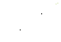

Service Manual
LR 100 / 300 / 500 / 700 / 1400 / -ST

Index

Working safety
  - General safety
  - Elektrical safety
  - Chemical and biological safety

Information about the unit
  - 2a. General information about the unit
  - 2b. Controller G-214
  - 2c. Model information

Troubleshooting / Repair
  - 3a. General operating problems
  - 3b. Troubleshooting schedule
  - 3c. Opening of the cooling system
  - 3d. Evacuation of the refrigerant
  - 3e. Changing the dryﬁlter
  - 3f. Changing the compressor
  - 3g. Pressure testing and leak detection
  - 3h. Vacuum suction / Vacuum check
  - 3i. Refrigerant ﬁlling with R134a (LR100/300/500/700/-ST) and R404a (LR1400/-ST)
  - 3j. Electrical troubleshooting
  - 3k. Electrical fault - compressor
  - 3l. HST-start relay, Start capacitor

Maintenance
  - 4a. Rubber gasket of the door
  - 4b. Heated door frame
  - 4c. Evaporator, Fan, Heat.element for aut. defrost and heating spiral in the defrost water drain
  - 4d. Condenser - fan
  - 4e. Door switch
  - 4f. Sensor for cold storage temperature
  - 4g. Controller - demounting the display
  - 4h. Automatical / manual defrost, cleaning and maintenance
  - 4i. Noise
  - 4j. Battery backup

Wiring diagrams and safety data sheet
  - 5a. Wiring diagram LR100/300/500/700/-ST and LR1400/-ST
  - 5b. Spare parts list LR100/300/500/700/1400/-ST
  - 5c. Safety data sheet R134a and R404a
  - 5d. Controller G-214
  - 5e. Default settings

2

- Working safety
This page provides general safety information for servicing the unit.
The instruction manual includes additional information about security and cleaning of unit.

General safety
To prevent personal and equipment damage, the electrical safety / legislation of your country must be observed.
    - 1. Never expose the moving parts of the plant to physical overload.
    - 2. When repairing plant parts, safety concerns must be respected.
    - 3. When using tools, spare parts and equipment, the existing security concerns must be met.
    - 4. Maintenance procedures described in this manuel must only be performed by trained personnel.

Electrical safety
Maintenance procedures may imply a voltage hazard. Follow existing safety instructions, including the low voltage and current EU directives and other derectives of your country.
Always disconnect the power to the unit before repair or parts replacement is initiated. Use only electrical equipment which is designed for the unit.

Chemical and biological safety
    - Always observe the requirements for safe handling, as descibed below.
    - Read the instruction manual before using, cleaning and servicing the unit.
    - Wear eye protection and gloves when working with refrigerants.
    - Skin contact with liquid refrigerants may cause frostbite.
    - Good ventilation and air extraction at the work area is required.
    - Stay in environments with high concentrations of refrigerant vapors is harmful.
    - Low concentrations may cause narcotic effects.
    - Symptoms of this may include: headache, shortness of breath, nausea and difﬁculties in concentration. Possibly: Mobility / consciousness.
    - Read the safety data sheet section 5d.

- Information about the unit
2a. General information about the unit

Motor compartment

White / stainless steel
exterior

Stainless steel
interior

Adjustable shelves

Heated door frame

Castors
Controller G-214

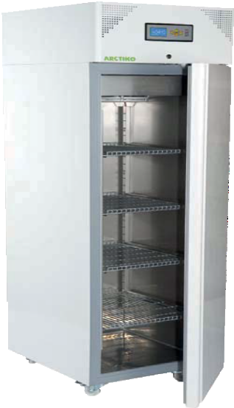Door key lock

Reversible door with soft stop

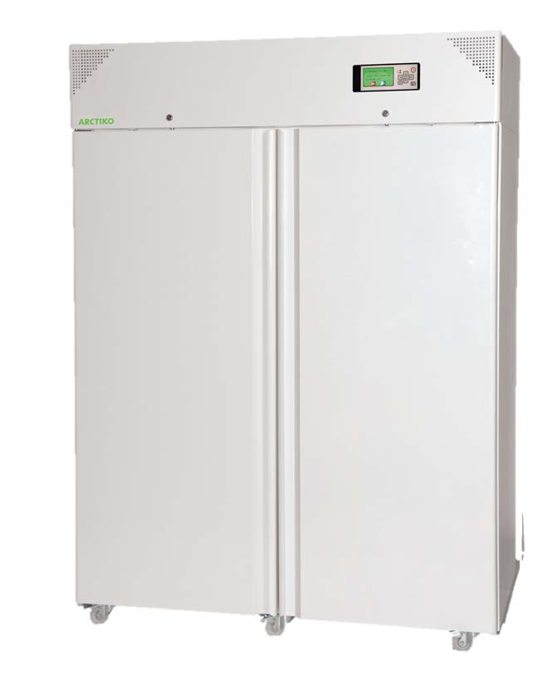
LR 1400 / -ST

LR 100 / -ST

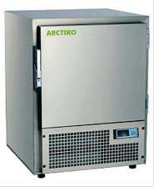Handle with lock and key

4 feet

Label plate located on the device
Model Voltage / Hz Compressor

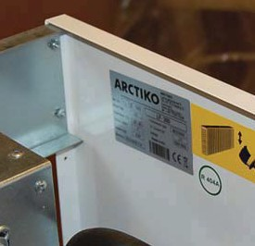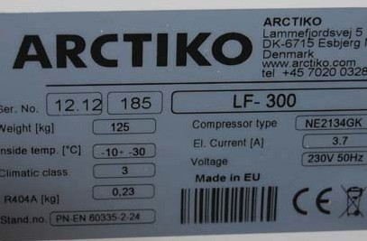
Refrigerant Filling Serial no. Power consumption
When contacting the supplier it is important to inform the model and serial no. The label plate is located behind the front panel in the engine compartment.
For technical problems: See troubleshooting schedule (3b).
Furthermore, the device is equipped with heated door frame.
The unit must be defrosted manually / automatically. See section 4h.

2b. Controller G-214
The PCB controller board is located in the engine compartment behind the front panel.
The display is mounted in the front panel.

Data controller:
- 72 hour battery backup for alarms.
- Microprocessor with digital display.
- Temperature disåplay and data acquisition during power failures.
- Visual and audible alarm.
- Adjustable high / lowtemperature / alarm.
- Integrated data logger.
- Automatic cycle of sensor failure.
- Measurement of the ambient air temperature.
- Direct download / upload from the USB memory stick.
- Display of battery voltage and ambient temperature.
- Integrated memory and data logger.
- RS 485/232 interface.
- Contact for remote alarm.
- Prepared for GSM alarm.
Alarm for:
- High / low temp.
- Voltage fault
- Sensor error
- Instrument error
- Front door
Display G-214
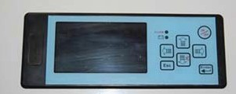

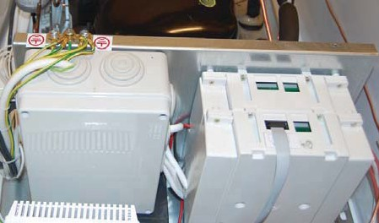
El-box PCB Board

Data sheet for controller G-214. See section 5d.

Model | LR 100 / -ST | LR 300 / -ST | LR 500 / -ST | LR 700 / -ST | LR 1400 / -ST
Item code | DAI  0280/0281 | DAI  0220/0221 | DAI  0240/0241 | DAI  0250/0251 | DAI  0270/0271
Temp. range 0C | +1/+10 | +1/+10 | +1/+10 | +1/+10 | +1/+10
Max. ambient temp. 0C | 43 | 43 | 43 | 43 | 43
Power supply (V) | 230 | 230 | 230 | 230 | 230
Frequency (Hz) | 50/60 | 50/60 | 50/60 | 50/60 | 50/60
Fuse (A) | 10 | 10 | 10 | 10 | 10
AMP (A) | 2,2 | 2,4 | 2,7 | 2,95 | 3,07
Power consumption  (KWh/24h) | 1,4 | 1 | 1 | 1,6 | 2
Compressor | See  labelplate | See  labelplate | See  labelplate | See  labelplate | See  labelplate
No. of Compressors | 1 | 1 | 1 | 1 | 1
Refrigerant / filling / gram | R134-A /  see labelplate | R134-A /  see labelplate | R134-A /  see labelplate | R134-A /  see labelplate | R4044-A /  see labelplate
Cabinet material on ST-models: Stainless steel
The compressor type can be found on the rating plate in the engine compartment.
The units may be provided with compressors of different brands, but with the same specific proper- ties.

Malfunction of the device, which can arise from improper handling of the device:

When moving or after long periods of inactivity, you must wait 1-2 hours before the unit is started.
When loading large quantities of items into the unit, the temperature will rise temporarily.
In case of repeated door openings, leaks or faulty gaskets, the humidity will cause rime and possi- bility of ice formation inside the device and around the door / interior door.
Use the troubleshooting schedule (section 3b).

3b. Troubleshooting schedule

Problem | Cause | Recommended equipment | Troubleshooting | Action
 | The socket or fuse is defect. |  | Check the instal- lation. | New fuse / plug.
 |  |  | Check power | Repair errors. Con-
The unit does not | Power cable is defect. | Universal | cables and wiring in the engine com-  partment. | sider using wiring  diagram section 5.
The unit does not | The controller is defect. | Universal | cables and wiring in the engine com-  partment. | Change controller.
freeze and the | The controller is defect. | Instrument |  | Change controller.
freeze and the | The sensor is defect. | Instrument | Test sensor. | See section 4l.
compressor does not start. | The sensor is defect. | test lamp. | Test sensor. | See section 4l.
compressor does not start. | Faulty windings in com- pressor | test lamp. | Test compressor windings. | See section 3k.
 | Start relay defect. |  | Test start relay. | See section 3l.
 | Fault in el-installation. |  | Use wire-diagram. | See section 5.
 |  | Voltmeter | Check voltage. | Find the cause.
 | Low voltage.
 | Defect or faulty start relay/capacitor. | See section 3m. | See section 3m. | Change start relay/ capacitor.
 | Defect compressor windings. | Ohmmeter | Check for electrical failure in the com- pressor. | Change compr.  See section 3f.
 | Defect rotor (compres- sor failure). |  |  | Change compr.  See section 3f.
The unit does not freeze. The com- pressor tries to start, but fails. | High pressure in the coolin system. | Tapping valve Manometer Filter | Open the system and rinse the sy- stem with nitrogen. | Remove 5 cm of the capillary tube. Change filter.  See section 3e.
 | The unit has been transported horizon- tally. |  |  | The unit must rest a few hours before start.
 | Ambient temp. low. Compr.oil too cold. | Eksternal thermo- meter | Check the tempe- rature. | Find a better place- ment.
 | May be general, if the | Eksternal thermo- | Check, that the | Find a better place-
 | ventilation is not suf- ficient. | meter. | compressor not exeeds 70°C. | ment or ventilation
 | Ambient temp. high. | Thermometer | Check ambient temp. | Find a better place- ment or ventilation

3b. Troubleshooting schedule

Problem | Cause | Recommended equipment | Troubleshooting | Action
The compressor runs constantly.  The unit freezes normaly or colder. | The sensor is in- correctly installed.
 | Sensor is defect.
 | Controller is dama- ged.
 | Icing on the frame. |  | Check the door for leaks. | See section 4a.
 | The temperature is set too low. |  | Check the settings in the controller. | Set new values. See section 5e.
The compressor starts normally, but stops again. | Too high voltage. | Voltmeter | Meassure the vol- tage. | Inform.
The compressor starts normally, but stops again. | Too high ambient temperature. | Eksternal thermometer | Check the tempe- rature and ventila- tion. | Better placement or ventilation.
The unit cools too much, too little or not at all.  The compressor may run conti- nuously | Leakage in the sy- stem. | Elektronic leak-seeking, soapy water, leak se- eking spray. | First check the sol- der points, compr., capacitor etc. | See section 3.
 | The fan is not run- ning. | Voltmeter | Ckeck for errors. | Replace the fan.  See section 4c.
 | The evaporator is blocked by ice.
The uint cools too much or nor at all..  Compressor runnin constant. | Little or no com- pressor capacity. | Service valve Manometer | Mount the valve and check pressure. | Change compres- sor.  See section 3f.
Insufficient cooling. | The device has recently been fil- led up with a large  amount of heat. |  |  | Inform the user.
Insufficient cooling. | In addition, tem- perature of the air is too high. | Eksternal thermometer | Check themperatur. | Find better ventila- tion or placement.
Insufficient cooling. | In addition, tem- perature of the air is too low. | Eksternal thermometer | Check themperatur. | Find better ventila- tion or placement.

8

Examples of troubleshooting with a manometer connected to the process piping of the cooling sy- stem.
The system is blocked:
Suction pressure is very low.
Pressure equalization takes place slowly or not at all.
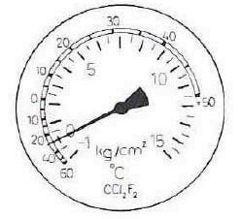
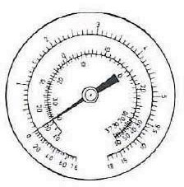
Reason: Icing or dirt in the capillary tube or ﬁlter, or blockings in the system due to other reasons.

Reason: No compressor capacity.
The suction pressure is too high.
The suction pressure does not change noticeably when the compressor stops. This can be tested with a volumetric meter.
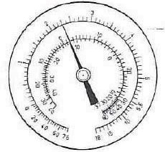

Leakage in the system.
The pressure gauge indicating insufﬁcient suction pressure. On the pressure side the temperature increases.
Pressure equalization time is short. countervailing pressure is lower than expected.
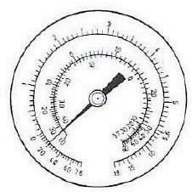
Be sure that the pressure is sufﬁcient for a pressure test.

3c. Opening of the cooling system
- To prevent moisture from penetrating under repair, the system must not be open for more than 15 minutes.
- Prepare spare parts components before the system is opened.
- The new connector is soldered to a tube with valve.

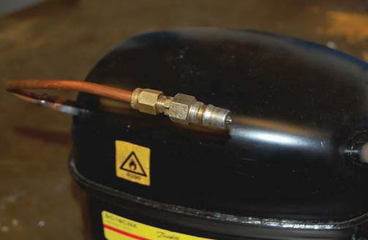

- Verify that the new ﬁlter packaging is intact and that the ﬁlter is not damaged.
- If the packaging has been broken for alonger period, the ﬁlter will bee moist.

3d. Evacuation of the refrigerant
- It is recommended that the compressor is running at least 25 min. before refrigerant eva- cuation is undertaken. This ensures that the system is hot, so that the refrigerant easier can be pulled out of the compressor oil.
- A drilling tongs with valve is placed on the process pipe.
- The refrigerant is evacuated.

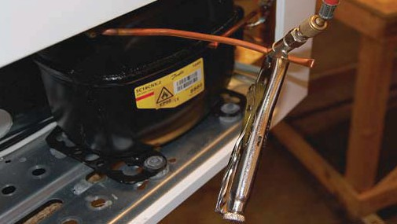

- Install a valve on the pressure tube and process pipe.

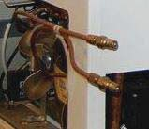
Process pipe and pressure tube ﬁtted with a valve.

- The cooling system is evacuated with a two-stage vacuum pump for at least 30 minutes. Both from the pressure piping and process piping.
- Blow the system with nitrogen, both from the suction and the pressure side.

3e. Changing the dryfilter
- The dry ﬁlter must pick up moisture in the system during opration and function as the capil- lary tube in front of the capillary tube, in order to avoid clogging. Clogged ﬁlter or capillary tube causes a pressure drop, by this the ﬁlter becomes colder and ice will block the system. The compressor is overloaded with a possibility of crash.
- The dry ﬁlter is placed after the condenser outlet, immediately before the capillary. Any ope- ning of the cooling system, dry ﬁlter change to ensure the function and lifetime of the unit.
- It is therefore recommended always to order a new ﬁlter drier, along with a new service cy- linder with cooling agent..
- To prevent moisture from penetrating during the repair, the drying ﬁlter must not be open for more than 10 min.
- After evacuation and blowing with nitrogen, the tubes must be cleaned on both sides of the ﬁlter drier, before cutting. By doing this the pipe ends are free from impurities and metal pie- ces and ready for soldering.
- Cut off the pressure pipe close to the ﬁlter with a pipe cutter.

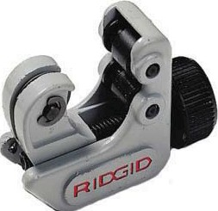
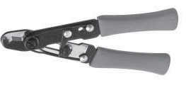

- Cut off the capillary tube with a capillary tube scissors.
- It is recommended to use a special tongs to create a wave on the capillary tube which en- sures the correct positioning in the ﬁlter.

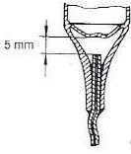
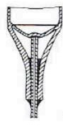
A | Right | a | B | 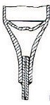  Wrong  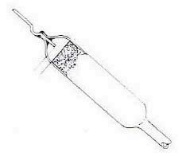
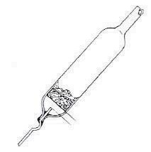
In the ﬁgure A the capillary tube is correctly installed in a dry ﬁlter. In order to ensure efﬁcient use of the ﬁlter, it must be positioned with an inclination of at least 150 and the capillary tube must be underneath.
In the ﬁgure B the capillary tube is too close too the web of the ﬁlter. It provides great resistan- ce and ﬁlter blocking after a short time. Or too far away, so it will be ﬁlled with ﬂux or solder.
- Solder the new ﬁlter.
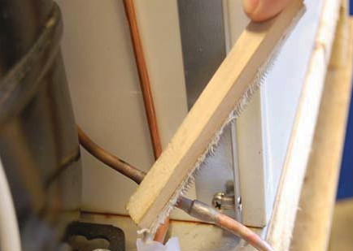
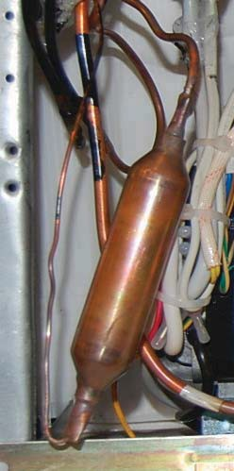
- Clean the solder points with a wire brush.

- Flush the system with nitrogen.
- If only the dry ﬁlter is to be replaced, the system must be pressure tested. See section 3g.

3f. Changing the compressor
- Evacuate the refrigerant of the system. See section 3d.
- All tubes are cut with a pipe cutter. Do NOT solder of.
- When replacing the compressor the dry ﬁlter must also be replaced. See section 3e.
- The suction and pressure pipes of the compressor must be cleaned and cut with a pipe cut- ter just above the soldering pipe.
- Demount the compressor.
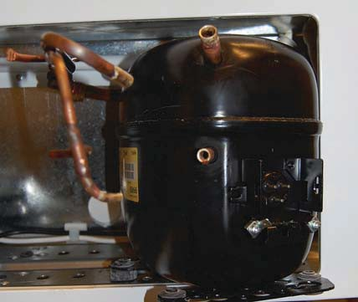
- Install the new compressor, which is prepared as described before. (3c)
- In order to avoid decomposition of refrigerants which may remain in the system during the soldering opreation, the system is blown with fry nitrogen, respectively, from the suction side respectively pressure side.
- Solder the tubes on to the compressor.
- Pressure test the system.

3g. Pressure testing and leak detection
- Pressure test the system with nitrogen. The pressure must be 10 bar during a period of 2 hours.
- Check the solder points with soapy water or leak detection spray.
- In case of any leaks, empty the system for nitrogen.
- Repair and pressure test again.
- During operation leak detection must be performed on the pressure side with the compres- sor running. The suction side must be tested while the compressor is stopped, and the pressures are equalized.
- The nitrogen must slowly be emptied from the system.



3h. Vacuum suction / Vacuum check
A vacuum is made on two locations on the system, one on the process tube and one on the pipe branch used for testing located on the pressure tube with an explosion-proof 2-stage vacuum pump.
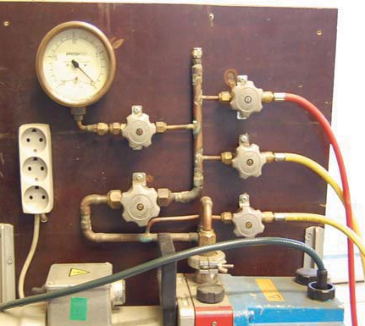
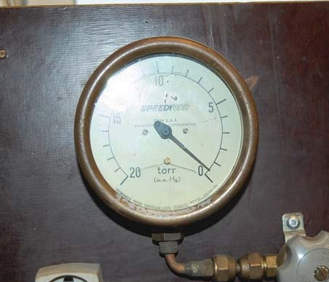
- The pressure should be 2 mBar or lower for at least 12 hours.
- The system is now ready for the ﬁlling of the refrigerant.

3i. Refrigerant filling with R134a / R404a
Before ﬁlling the refrigerant, a vacuum must be suched. See section 3h.
Note that R134a / R404a is to be supplied from a bottle containing a speciﬁc amount of refrigerant. Common procedures for other refrigerants can not be used.
Further it is important that the entire contents of the bottle is introduced into system to ensure opti- mal performance.
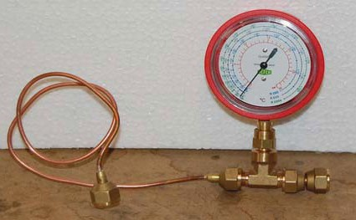
The contents of the bottle must be mixed before use by shaking the bottle for at least 1 min. before the ﬁlling.
In order to perform the ﬁlling operation properly, it is ne- cessary to use a capillary tube with the valve before the ﬁlling site, instead of a conventional feeding tube. The reason is that the capillary tube ensures that the entire quantity of refrigerant is introduced to the system, If an ordinary ﬁller is used, it must be as short as possible.

The refrigerant cylinder is weighed before use.

14



Cylinder with manometer Vacuum suction of the ﬁlling hose
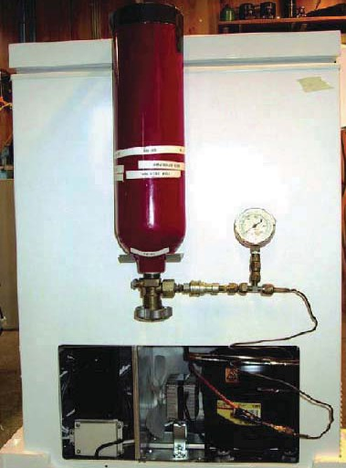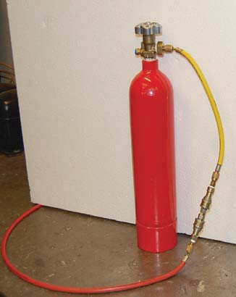
Loading procedure
Make vaccum. See section 3h.
The cylinder with manometer is connected to the coupler of the process piping.
Remember f rst to made vacuum in the f lling hose to empty it.
Fill the refrigerant into the system until the pressure gauge on the pressure tube shows approx. 5 bar.
Start the compressor and let it run for 2-3 min. Open to the cylinder again to get out the remaining refrigerant.
When the pressure in the bottle shows 1 bar, the bottle is empty.
It is important that the valve is closed immediatly, in order to avoid that the refrigerant runs back into the cylinder.
Now the cooling system is ﬁlled with refrigerant and only needs to be closed. Disconnect the ﬁlling hose with pressure gauge from the process piping.
Push the process piping ang pressure pipes together with a special tongs. Cut off valve with a pipe cutter.
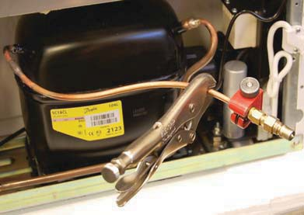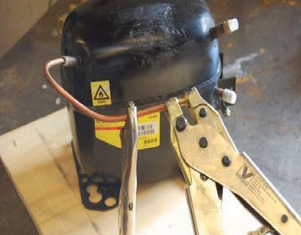
Closing the process tube on systems with ﬂammable refrigerants must be performed by professionals with a LokRing ens sleeve. It is recommended NOT to solder system.
Clean the pipe with steel wool or emery cloth. Use rotational movement in order to avoid scratching the length of the tube.
Apply LokPreb to the end of the tube.
Turn the end sleeve 360°, so that the LokPreb is placed around the tube. Squeeze the end sleeve together with the special tool as shown in the illustration.. Start the unit and control the function of the device.

15

3j. Electrical troubleshooting

Before starting systematic troubleshooting, check the following:
- Proper voltage is present.
- Electrical equipment used, is suitable for the compressor.
- The wires are properly installed according to wiring diagram.
- There is no tranition between the live parts and ground.

Control of the transition to ground.
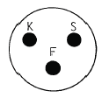
In order to check whether there is a transition between the conducting components and the chas- sis, the insulation resistance is tested by using an Ohmmeter or the second high-voltage equip- ment. An Ohmmeter can be used for a rough check. The Ohmmeters one clamp is placed on the compressors ground terminal. The second clamp on the compressor shared leg (see sketch). Is the Ohmmeter showing a transition, the compressor is replaced.

Plug on the compressor

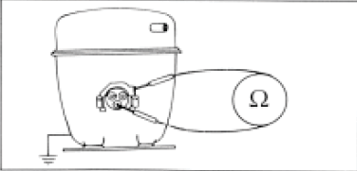
Shared leg Ground terminal
Uses high voltage test systems with ﬂammable refrigerants, ensure that the system is completely drained of coolant. as this can cause sparks during the test.



3k. Electrical fault - compressor

Remove the start relay from the compressor and use an Ohmmeter to test the compressor head and start recovery. Connect the Ohmmeter between the common connector and start winding, then the main winding to debug. See the picture below.

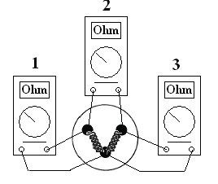

Dimensions of the compressor connections to determine whether driving and start winding are in- tact.
This is done by measuring the resitance of these. Carry out three resistance measurements on compressor penetrations. The sum of the two smallest measurements, the intact windings will be equel to the highest. Find if the current values of the compressor data sheet.

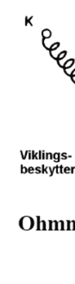By measuring the compressors with built winding protec- tion it is extremely important to measure between K and S, as this measure will tell if this is burnt windings or an open winding protector.
Winding protector
Ohm-measurement

Since it is relatively small value to be measured, it would be a great advantage to use a digital Ohm-meter.

If the measurement inicates error, the compressor is replaced.

17

3l. HST-start relay, start capacitor

Connect a voltmeter between terminals 10 and 13 at the start of the relay. If no voltage is present, there is eigther a faulty cable or also the start relay is defect.

Connect a voltmeter between terminals 10 and 14. If no voltage is present, the temperature sensor or its cable is defect.

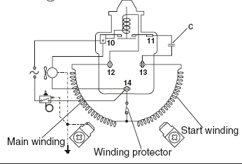

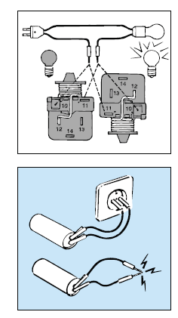
A relay can be checked with an indicator light as shown in the sketch maintain end. The relay is usu- ally ok, when in standing position is not lit, and when it is lit when the relay is upside down.

The start capacitor can be checked by injecting the normal voltage for a few seconds and than shorting it. When sparks are generated, the capacitor is in order.

When replacing the compressor the start relay and the start capacitor should also be replaced. The start relay is placed and clamped on the three terminal pins on the compressor.
The voltage is connected to terminals 10 and 14.
The start capacitor is connected and clamped to terminals 11 and 13.

b. Cover e. The compressor blades c. Start capacitor

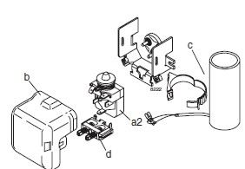d. Wire hanger a2. Start relay

Maintenance
4a. Rubber gasket of the door
Rub the gasket with a suitable product, so that it stays ﬂexible and the optimal function and tight- ness is secured.
Make sure the door closes tightly so that no ice forms around the door frame.
  - Open the door and place a piece of paper. Close the door.
  - Pull the paper.
  - If the paper can not be pushed back, the adjustment is OK.
  - The test is made at both the left and the right side.
  - In case that the gasket do not close properly, see section 4b.

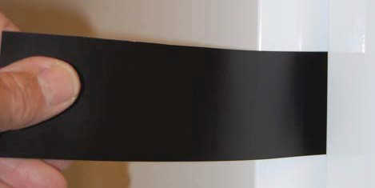
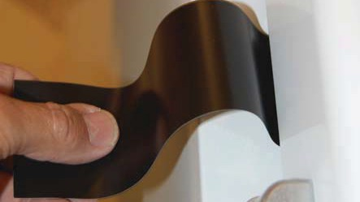

The door can be adjusted in the slots in the top hinge of the door in the motor compartment.
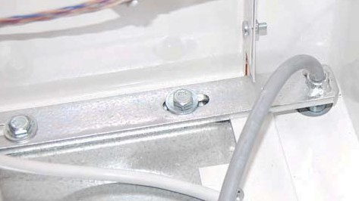
Adjusting

4b. Heated door frame

The heaters are installed in the door frame .
Electrically, the cable (220V) is supplied by the PCB board and assembled in the controller box. See the wiring diagram section 5a.
The cable is introduced to the door frame on the front of the engine compartment behind the front panel.

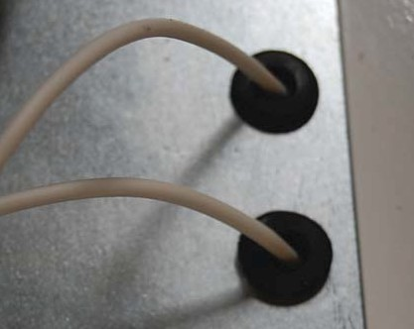

4c. Evaporator, Fan, Heat.element for aut. defrost and heating spiral in the defrost water drain
The evaporator is placed at the top of the cold storage.
The fan runs continuously when the unit is connected and ensure god air distribution in the cold sto- rage.
The fan stops when the door is opened and during the automatic defrost.
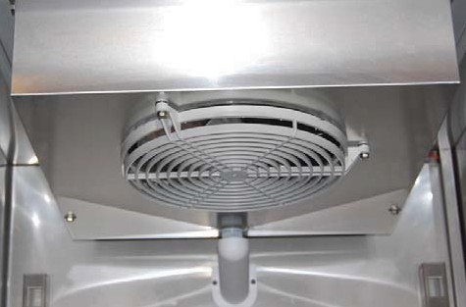
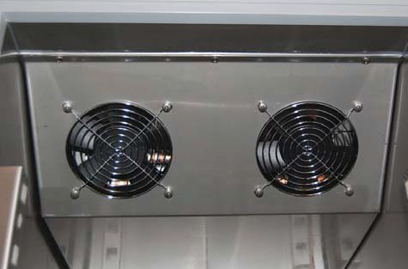
To avoid ice formation in the defrost water tray, a heater is mounted in the drain pipe to the drain tray.
Fan LR 500 - 700 - 1400 (2 pcs.) Fan LR 300

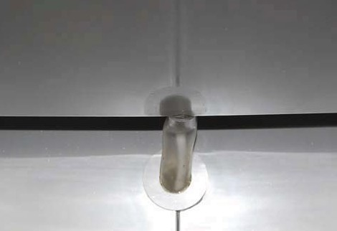

Heater in the drain pipe

To get into the evaporator, the sensor for evaporator temperature and the heating element the drain is removed. Then remove the drain tray (4 screws).
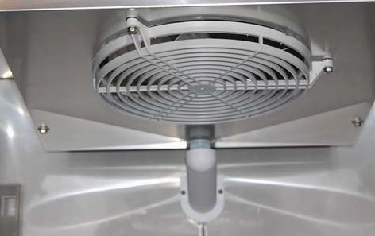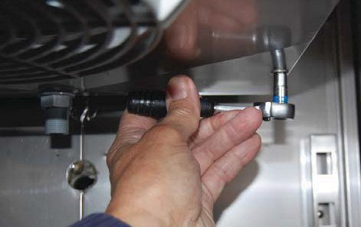
Remove the drain pipe Remove the drain tray

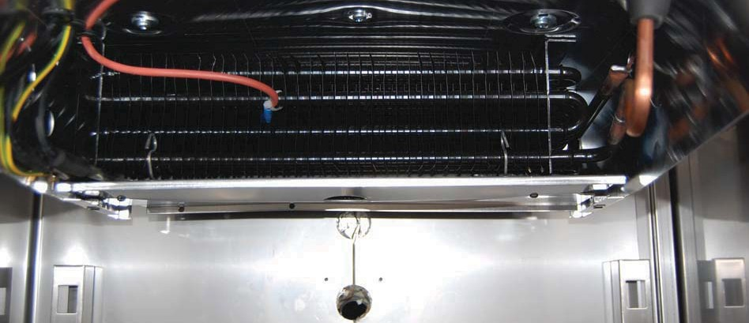
Heating element The sensor for evaporator

Sensor lead, wire for ventilation and heater as seen from the top of the motor compartment.
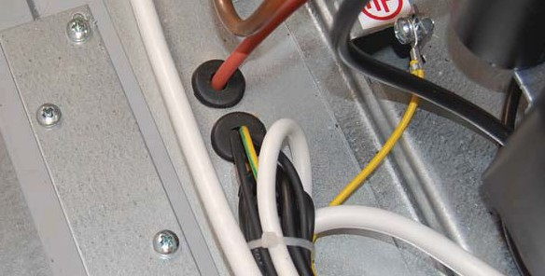

4d. Condenser - Fan
The condenser is placed in the engine department of the uit behind the front panel.
Check that the bolts are well tightened and that the rubber gaskets at the fan are not hard or defec- tive. It is important thet the cooling ribs are kept clean and the ambient temperature does not exeed 25°C.
Physically, the fan is placed on the frame of the capacitor.
Electrically, the fan is connected to terminal 10 and 14 on the start relay. See wiring diagram section 5a.
If the ventilator stops, it can cause insufﬁcient cooling of condenser and compressors.
Higher condensing temperature means that the compressor must work more with less efﬁciency as a result. At worst, the compressors stops due to high temperature.

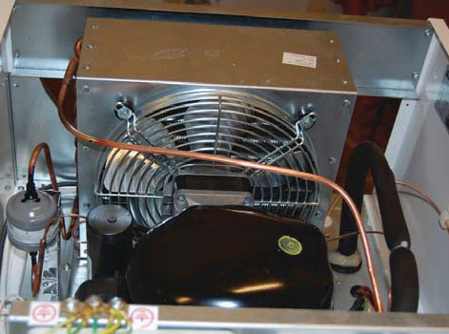
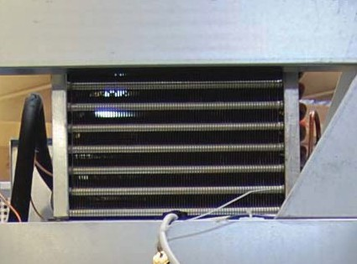
Fan Cooling ribs

4e. Door switch
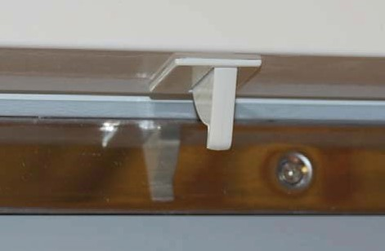
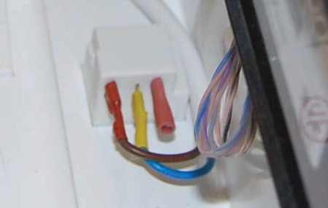
Door switch under the top panel Door switch in the motor compartment

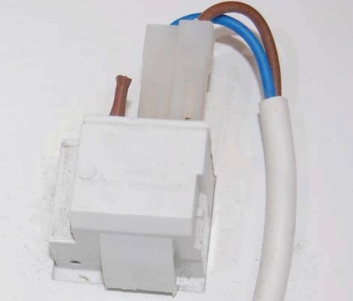
Push here when remounting

The door switch function controls:
Start/stop of the evaporator fan. On/off light.
Alarm for open door.

The door switch is clipped under the door panel. When replacing remove wire.
The ﬂaps are pushed together and the switch is pressed out. A new switch is mounted in reverse order.

4f. Sensor for cold storage temperature
Sensor for evapoarator tube temperature:
The sensor is the type of PT 1000.
The sensor must be introduced from the top of the motor compartment as the sensor for the room temperature.
The sensor i placed at the top of the evaporator in the cold storage covered by the drain cover. To remove the sensor, remove the cover. (See section 4c)
The sensor is fastened with strips.
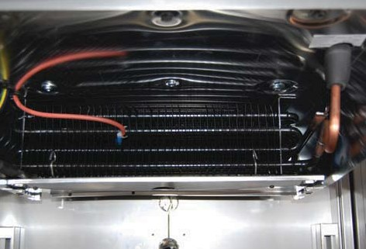
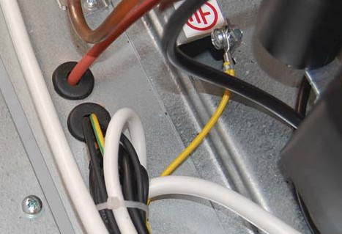The sensor is connected to the PCB board input. (See wire-diagram section 5a)
Evaporator Sensor wire

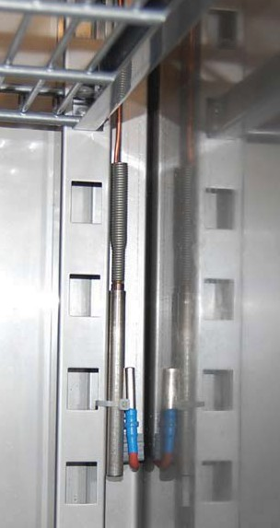Sensor for cold storage temperature:
The PT 1000 sensor for cold storage temperature is placed on the right side fastened with strips.
The sensor must be introduced from the top of the motor compart- ment.
The holes are sealed with putty.
Elecrically, the sensor is connected to the PCB board input (Temp. sensors - Chamber).
See wire-diagram sectiont 5a.

Change of probe: Sensor track
  - Disconnect the power supply.
  - Disconnect the electrical connection of the sensor in the CBS modul.
  - Remove the strips. PT 1000 sensor
  - Remove the sensor track.
  - Pull the sensor into the motor compartment.
  - Mount the new sensor in reverse order. Sensor for possible Chart-recorder

4g. Controller - demounting the display
Demount of display
  - Disconnect the wire connector on the bottom of the display.
  - Squeeze the mounting devices at the bottom and top together and push out the display.

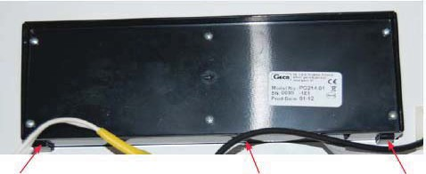
Mounting device Wire connectors Mounting device

4h. Automatical / manual defrost, cleaning and mainte- nance
There will be some ice formation on the sub lids of the unit.
The ice must be removed with a scraper on a regular basis. (Remember safety gloves) Ice on the inside of the cabinet must be removed as required.
This is done by manual defrost:
  - Remove the contents of the unit.
  - Unplug the unit.
  - Leave the door open until the ice can be removed.
  - Wipe the interior cabinet and shelves with a cloth until it is dry.
Ice formed on the inside of the door, must be removed with a wooden / plastic scraper. This ice is formed due to the low temperatures inside the cabinet, and if the ice is not removed, it will cause that the door does not close tightly.

Automatic defrost cycles in G 214 controller.
As default the controller will run automatic defrost every 6 hours.
- The automatic defrost cycles start.
- The compressor stop.
- The evaporator-fan stop.
- The evaporator-heat element starts heating up the evaporator.
- The evaporator-sensor is measuring the temperature in the evaporator.
- When the temperature in the evaporator reach -5°C., the heat element stop. parameter d9
- The ice which was build up in the evaporator, will get into liquid form, and start floating out of the cham- ber, into the water tray on the back of the unit.
- The parameter c3 is the time for the water can drip of the evaporator when the heat element has switch off.
- After the C3 dripping time, the compressor start running again.
- The parameter C13 will determine when the evaporator fan is starting, if the temperature d8 has been reached.
- When the temperature in the evaporator reach -5°C., the evaporator-fan start running again.
- The automatic defrost cycles end.
C7 is the paramet which block the display to measure the temperature in the chamber. Examble: If the dis- play show -28° before the defrost starts, the display will show -28°C during the defrost cycles and 5 minutes (c7) after the defrost is finished. After the 5 minutes the display will show the actually temperature again.
The parameter c14 is start blocking time defrost cycles.
The parameter c15 is the end time of blocking defrost cycles.
Examble : If the customer do not want the unit to be defrosted in normally working hour, 8 o’clock until 16 o’clock.
c14 : 8 and c15 :16, now the unit will not do any defrost cycles in between these hours.
During the automatic defrost cycles, the displayed temperature will show the temperature in the air. This is not the actually temperature which are in the samples of medicine or similar product.
The temperature will be dropping approx. 2°C in the samples, during the automatic defrost.

4i. Noise
The following must be checked in case of noise:
  - The compressor is not tightened well.
  - The rubber feet are defect or too hard.
  - The compressor process tube is too long.
  - The fan blades are damaged or dirty.
  - The fan is not tightened well.
  - The fan bushings are worn.
  - The freezer is not positioned on a ﬂat surface.
  - Long pipes can cause resonance vibrations.
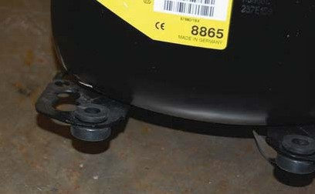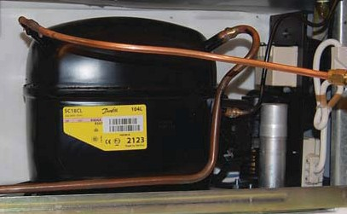
Rubber feet Process tube (too far)

4j. Battery backup
The battery (12V 7AH) is located in the engine compartment behind the front panel. It has a lifespan of 3 yerars, but should be checked every six months.
Check the voltage with a voltmeter.
The controller G-214 has built-in measurer for the battery voltage.

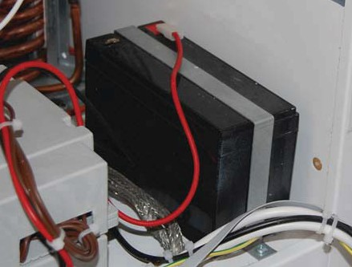Backup-battery

5a. Wiring-diagram LR 100 / 300 / 500 / 700 / -ST

PT1000 T3
PT1000 T2
NTC NTC
SENSORS

100-240V AC

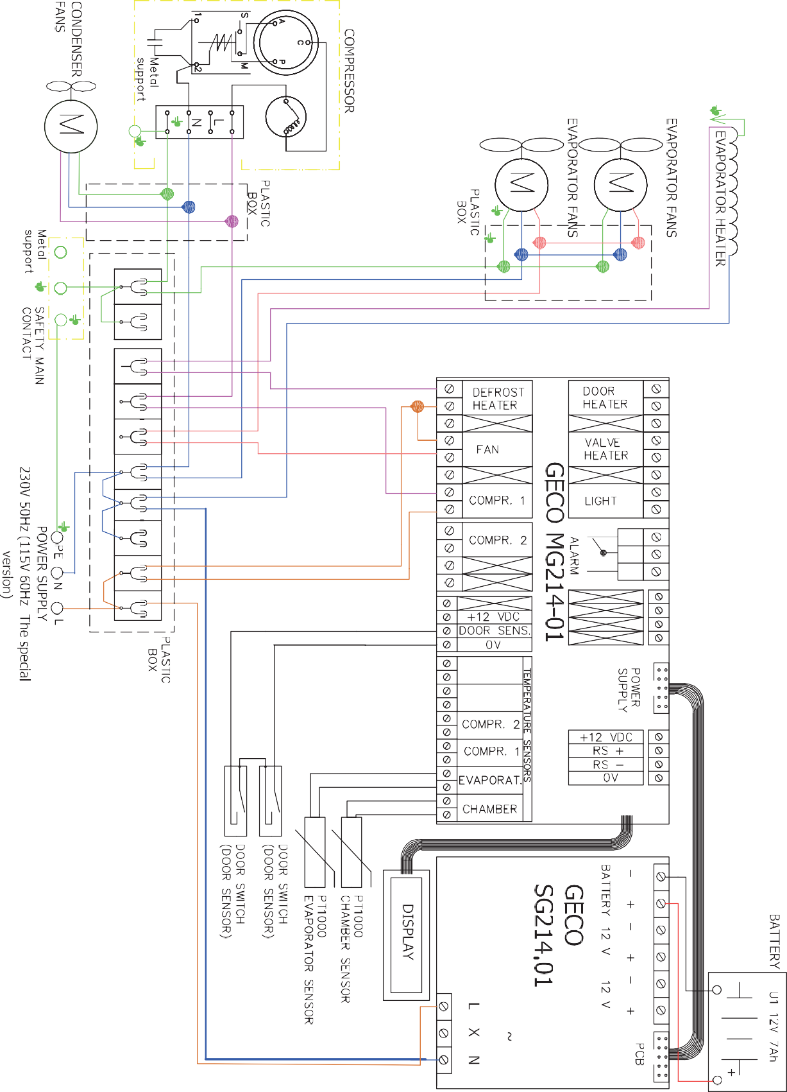
5a. Wiring-diagram LR 1400 / -ST

PT1000 T3
PT1000 T2
NTC NTC

100-240V AC

5b. Spare parts list LR 300 / 500 / 700 /-ST

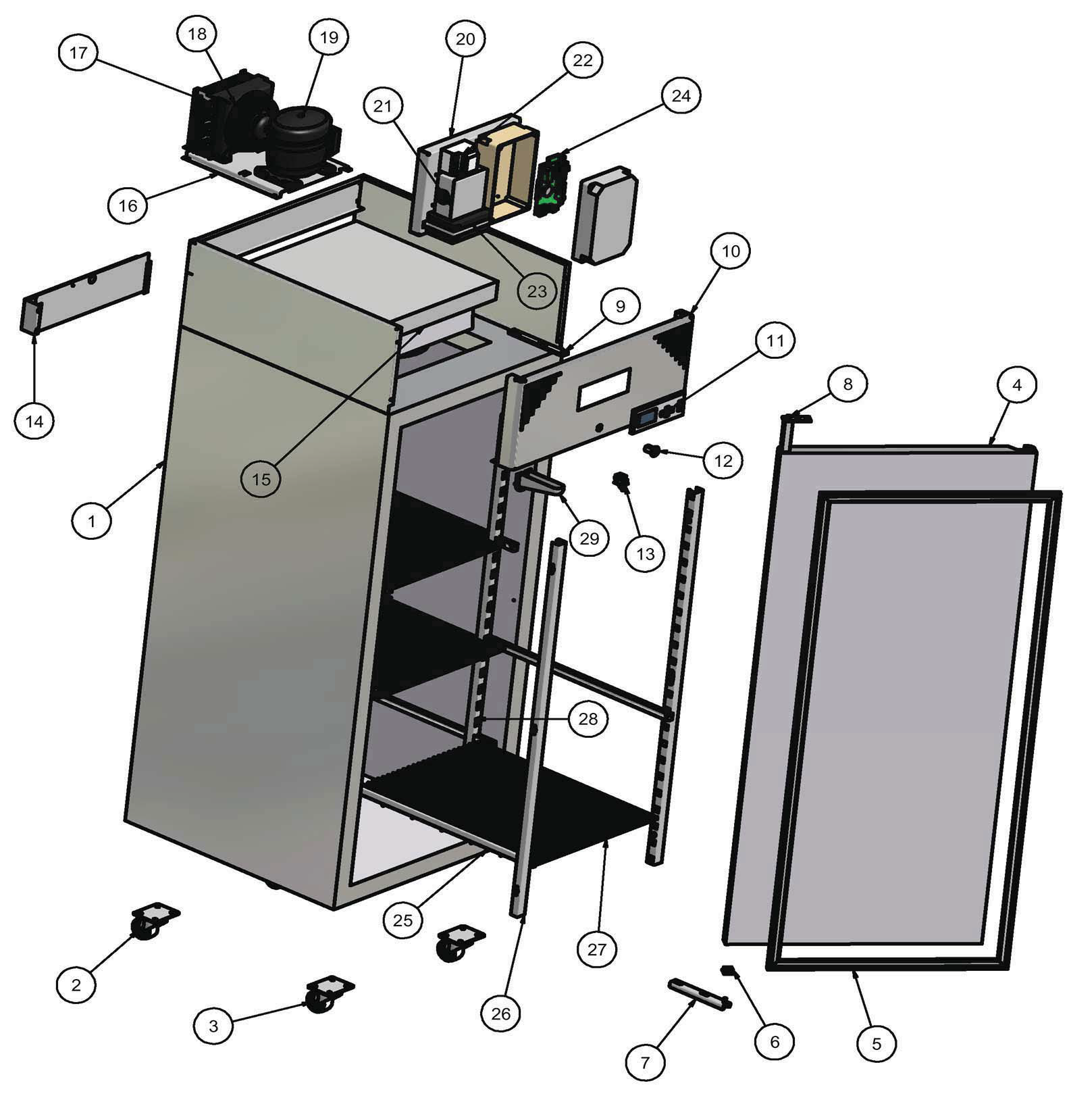24

5b. Spare parts list LR 300 / 500 / 700 /-ST

Pos. no. | Code no. | Part | Recommended
1 |  | Cabinet stainless steel
1 |  | Cabinet whit
2 | 5053006-01 | Back castor swivel without brake
3 | 5053007-01 | Front castor swivel with brake
4 |  | Door stainless steel
4 |  | Door white
5 |  | Gasket
6 | 5031033-01 | Door sleeve
7 | 5031034-01 | Door lower support
8 | 5031012-01 | Spring hinge
9 | 5031041-01 | Door upper support
10 |  | Front panel Stainless steel
10 |  | Front panel White
11 | 5043007-01 | Display G-214 | 1
11a | 5031028-01 | Installation plate for display
12 | 5051015-01 | Lock with key
13 | 5019022-01 | Fan switch
14 | 5031036-01 | Defrost water tank
15 | 5073023-01 | Evaporator
16 | 5031138-01 | Condenser and compressor support
17 | 5071007-01 | Condenser
18 | 5010007-01 | Condenser fan incl. fan blade
19 |  | Compressor
21 | 5049013-01 | Electrical box with support
23 | 5044001-01 | Battery BP 7-12 (12V, 7AH) | 1
24 | 5041006-01 | PCB Board G-214 Controller | 1
25 | 5062010-01 | Shelf guide
26 | 5062001-01 | Shelf support front
27 |  | Shelf
28 | 5062001-01 | Shelf support back
29 | 5030081-01 | Drain
- |  | Evaporator body
- | 5041007-01 | Power supply G-214 | 1
- | 5019139-01 | Power supply support
- | 5042016-01 | Probe NTC for compressor | 1
- | 5042003-01 | Probe for chamber (PT1000)) | 1
- | Finans no. | Refrigerant
- | 5072000-01 | Cylinder deposit for refrigerant
- | 5079000-01 | Dry filter
- | 5049007-01 | Box for PCB bord connection.

5b. Spare parts list LR 1400 /-ST

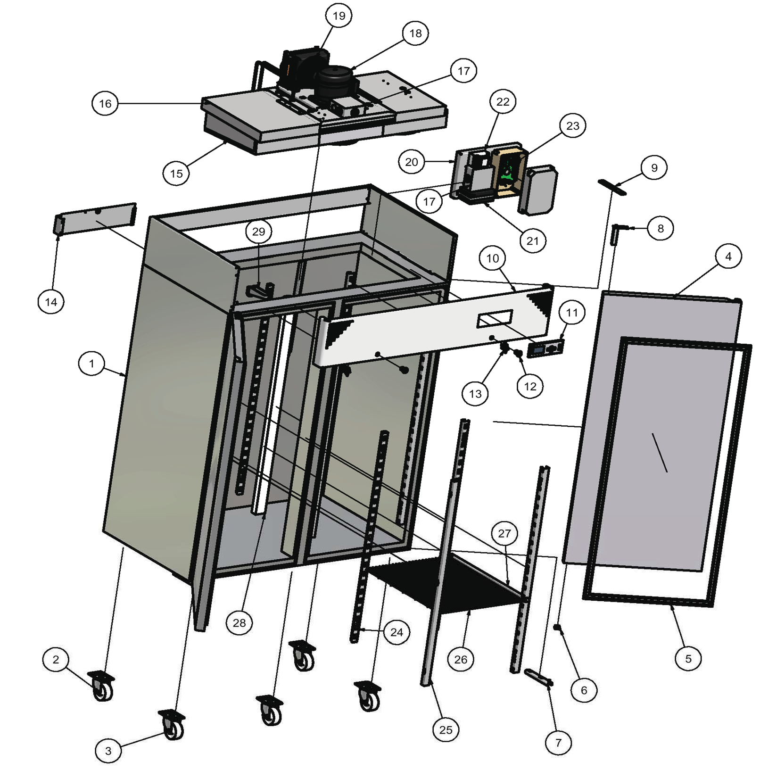18
19

24

21

23

25

28
27

26

5b. Spare parts list LR 1400 /-ST

Pos. no. | Code no. | Part | Recommended
1 |  | Cabinet stainless steel
1 |  | Cabinet white
2 | 5053006-01 | Back castor swivel without brake
3 | 5053007-01 | Front castor swivel with brake
4 | 5052029-01 | Door stainless steel
4 | 5052024-01 | Door white
5 | 5052107-01 | Gasket
6 | 5031033-01 | Door sleeve
7 | 5031034-01 | Door lower support
8 | 5031012-01 | Spring hinge
9 | 5031041-01 | Door upper support
10 | 5050081-01 | Front panel Stainless steel
10 | 5050006-02 | Front panel White
11 | 5043007-01 | Display G-214 | 1
11a | 5031028-01 | Installation plate for display
12 | 5051015-01 | Lock with key
13 | 5019022-01 | Fan switch
14 | 5031036-01 | Defrost water tank
15 | 5073025-01 | Evaporator
16 | 5031138-01 | Condenser and compressor support
17 | 5049006-01 | Box for 230 V connections
18 |  | Compressor
19 | 5071008-01 | Condenser
19a | 5010007-01 | Condenser fan incl. fan blade
21 | 5044001-01 | Battery BP 7-12 (12V, 7AH) | 1
23 | 5041006-01 | PCB Board G-214 Controller | 1
24 | 5062001-01 | Shelf support back
25 | 5062001-01 | Shelf support front
26 | 5060002-01 | Shelf
27 | 5062010-01 | Shelf guide
28 | 5019004-01 | Light
29 | 5030081-01 | Drain
- |  | Evaporator body
- | 5041007-01 | Power supply G-214 | 1
- | 5019139-01 | Power supply support
- | 5042016-01 | Probe NTC for compressor | 1
- | 5042003-01 | Probe for chamber (PT1000) | 1
- | Finans no. | Refrigerant
- | 5072000-01 | Cylinder deposit for refrigerant
- | 5079000-01 | Dry filter
- | 5049007-01 | Box for PCB bord connection.

5c. Safety data sheet for R-134A

Material Safety Data Sheet
R-134A
1. CHEMICAL PRODUCT AND COMPANY IDENTIFICATION PRODUCT NAME: R-134A
DISTRIBUTOR: National Refrigerants, Inc.
661 Kenyon Avenue Bridgeton, New Jersey 08302
FOR MORE INFORMATION CALL: IN CASE OF EMERGENCY CALL:
(Monday-Friday, 8:00am-5:00pm) CHEMTREC: 1-800-424-9300 1-800-262-0012
2. COMPOSITION / INFORMATION ON INGREDIENTS INGREDIENT NAME CAS NUMBER WEIGHT %
1,1,1,2-Tetrafluoroethane 811-97-2 100
Trace impurities and additional material names not listed above may also appear in Section 15 toward the end of the MSDS. These materials may be listed for local “Right-To-Know” compliance and for other reasons.
3. HAZARDS IDENTIFICATION

EMERGENCY OVERVIEW: Colorless, volatile liquid with ethereal and faint sweetish odor. Non-flammable material. Overexposure may cause dizziness and loss of concentration. At higher levels, CNS depression and cardiac arrhythmia may result from exposure. Vapors displace air and can cause asphyxiation in confined spaces. At higher temperatures,
(>250°C), decomposition products may include Hydrofluoric Acid (HF) and carbonyl halides.

POTENTIAL HEALTH HAZARDS
SKIN: Irritation would result from a defatting action on tissue. Liquid contact could cause frostbite.
EYES: Liquid contact can cause severe irritation and frostbite. Mist may irritate.
INHALATION: R-134A is low in acute toxicity in animals. When oxygen levels in air are reduced to 12-14% by displacement, symptoms of asphyxiation, loss of coordination, increased pulse rate and deeper respiration will occur. At high levels, cardiac arrhythmia may occur.
INGESTION: Ingestion is unlikely because of the low boiling point of the material. Should it occur, discomfort in the gastrointestinal tract from rapid evaporation of the material and consequent evolution of gas would result. Some effects of inhalation and skin exposure would be expected.
DELAYED EFFECTS: None Known

MSDS: R-134A Page 1 of 7
Current Issue Date: December, 2008

Ingredients found on one of the OSHA designated carcinogen lists are listed below.
INGREDIENT NAME NTP STATUS IARC STATUS OSHA LIST
No ingredients listed in this section

4. FIRST AID MEASURES

SKIN: Promptly flush skin with water until all chemical is removed. If there is evidence of frostbite, bathe (do not rub) with lukewarm (not hot) water. If water is not available, cover with a clean, soft cloth or similar covering. Get medical attention if symptoms persist.
EYES: Immediately flush eyes with large amounts of water for at least 15 minutes (in case of frostbite, water should be lukewarm, not hot) lifting eyelids occasionally to facilitate irrigation. Get medical attention if symptoms persist.
INHALATION: Immediately remove to fresh air. If breathing has stopped, give artificial respiration. Use oxygen as
required, provided a qualified operator is available. Get medical attention immediately. DO NOT give epinephrine (adrenaline).
INGESTION: Ingestion is unlikely because of the physical properties and is not expected to be hazardous. DO NOT induce vomiting unless instructed to do so by a physician.
ADVICE TO PHYSICIAN: Because of the possible disturbances of cardiac rhythm, catecholamine drugs, such as epinephrine, should be used with special caution and only in situations of emergency life support. Treatment of overexposure should be directed at the control of symptoms and the clinical conditions.
5. FIRE FIGHTING MEASURES FLAMMABLE PROPERTIES
FLASH POINT: Gas, not applicable per DOT regulations
FLASH POINT METHOD: Not applicable
AUTOIGNITION TEMPERATURE: >750°C
UPPER FLAME LIMIT (volume % in air): None*
LOWER FLAME LIMIT (volume % in air): None*
*Based on ASHRAE Standard 34 with match ignition
FLAME PROPAGATION RATE (solids): Not applicable
OSHA FLAMMABILITY CLASS: Not applicable
EXTINGUISHING MEDIA:
Use any standard agent – choose the one most appropriate for type of surrounding fire (material itself is not flammable)
UNUSUAL FIRE AND EXPLOSION HAZARDS:
R-134A is not flammable at ambient temperatures and atmospheric pressure. However, this material will become combustible when mixed with air under pressure and exposed to strong ignition sources.
Contact with certain reactive metals may result in formation of explosive or exothermic reactions under specific conditions (e.g. very high temperatures and/or appropriate pressures).

MSDS: R-134A Page 2 of 7
Current Issue Date: December, 2008

SPECIAL FIRE FIGHTING PRECAUTIONS/INSTRUCTIONS:
Firefighters should wear self-contained, NIOSH-approved breathing apparatus for protection against possible toxic decomposition products. Proper eye and skin protection should be provided. Use water spray to keep fire-exposed containers cool.

6. ACCIDENTAL RELEASE MEASURES

IN CASE OF SPILL OR OTHER RELEASE: (Always wear recommended personal protective equipment.) Evacuate unprotected personnel. Protected personnel should remove ignition sources and shut off leak, if without risk, and provide ventilation. Unprotected personnel should not return until air has been tested and determined safe, including low- lying areas.
Spills and releases may have to be reported to Federal and/or local authorities. See Section 15 regarding reporting requirements.

7. HANDLING AND STORAGE

NORMAL HANDLING: (Always wear recommended personal protective equipment.) Avoid breathing vapors and liquid contact with eyes, skin or clothing. Do not puncture or drop cylinders, expose them to open flame or excessive heat. Use authorized cylinders only. Follow standard safety precautions for handling and use of compressed gas cylinders.
R-134A should not be mixed with air above atmospheric pressure for leak testing or any other purpose.
STORAGE RECOMMENDATIONS:
Store in a cool, well-ventilated area of low fire risk and out of direct sunlight. Protect cylinder and its fittings from physical damage. Storage in subsurface locations should be avoided. Close valve tightly after use and when empty.
8. EXPOSURE CONTROLS / PERSONAL PROTECTION ENGINEERING CONTROLS:
Provide local ventilation at filling zones and areas where leakage is probable. Mechanical (general) ventilation may be
adequate for other operating and storage areas.
PERSONAL PROTECTIVE EQUIPMENT SKIN PROTECTION:
Skin contact with refrigerant may cause frostbite. General work clothing and gloves (leather) should provide adequate protection. If prolonged contact with liquid or gas is anticipated, insulated gloves constructed of PVA, neoprene or butyl rubber should be used. Any contaminated clothing should be promptly removed and washed before reuse.
EYE PROTECTION:
For normal conditions, wear safety glasses. Where there is reasonable probability of liquid contact, wear chemical safety goggles.

MSDS: R-134A Page 3 of 7
Current Issue Date: December, 2008

RESPIRATORY PROTECTION:
None generally required for adequately ventilated work situations. For accidental release or non-ventilated situations, or release into confined space, where the concentration may be above the PEL of 1,000 ppm, use a self- contained, NIOSH approved breathing apparatus or supplied air respirator. For escape: use the former or a NIOSH approved gas mask with organic vapor canister.
ADDITIONAL RECOMMENDATIONS:
Where contact with liquid is likely, such as in a spill or leak, impervious boots and clothing should be worn. High dose-level warning signs are recommended for areas of principle exposure. Provide eyewash stations and quick- drench shower facilities at convenient locations. For tank cleaning operations, see OSHA regulations, 29 CFR 1910.132 and 29 CFR 1910.133.
EXPOSURE GUIDELINES
INGREDIENT NAME | ACGIH TLV | OSHA PEL | OTHER LIMIT
1,1,1,2-Tetrafluoroethane | None | None | *1000 ppm TWA (8hr)
* = Workplace Environmental Exposure Level (AIHA)
OTHER EXPOSURE LIMITS FOR POTENTIAL DECOMPOSITION PRODUCTS:
Hydrogen Fluoride: ACGIH TLV: 2 ppm ceiling, 0.5 ppm TLV-TWA

9. PHYSICAL AND CHEMICAL PROPERTIES

APPEARANCE: Clear, colorless liquid and vapor
PHYSICAL STATE: Gas at ambient temperatures
MOLECULAR WEIGHT: 102
CHEMICAL FORMULA: F3CCH2 F
ODOR: Faint ethereal odor
SPECIFIC GRAVITY (water = 1.0): <1.22
SOLUBILITY IN WATER (weight %): 0.15 wt%
pH: Neutral
BOILING POINT: -26.2°C (-15.1°F)
FREEZING POINT: -92.5°C (-141.9°F)
VAPOR PRESSURE: 85.8 psia @ 70°F
213.4 psia @ 130°F
VAPOR DENSITY (air = 1.0): 3.5
EVAPORATION RATE: >1 COMPARED TO: CC14 = 1
% VOLATILES: 100
FLASH POINT: Not applicable
(Flash point method and additional flammability data are found in Section 5.)

MSDS: R-134A Page 4 of 7
Current Issue Date: December, 2008

10. STABILITY AND REACTIVITY

NORMALLY STABLE? (CONDITIONS TO AVOID):
The product is stable.
Do not mix with oxygen or air above atmospheric pressure. Any source of high temperatures, such as lighted cigarettes, flames, hot spots or welding may yield toxic and/or corrosive decomposition products.
INCOMPATIBILITIES:
(Under specific conditions: e.g. very high temperatures and/or appropriate pressures) – Freshly abraded aluminum surfaces (may cause strong exothermic reaction). Chemically reactive metals: potassium, calcium, powdered aluminum, magnesium, and zinc.
HAZARDOUS DECOMPOSITION PRODUCTS:
Halogens, halogen acids and possibly carbonyl halides.
HAZARDOUS POLYMERIZATION:
Will not occur.
11. TOXICOLOGICAL INFORMATION IMMEDIATE (ACUTE) EFFECTS:
LC50 : 4 hr. (rat) - > 500,000 ppm / Cardiac Sensitization threshold (dog) 80,000 ppm. NOEL – 50,000 ppm
DELAYED (SUBCHRONIC AND CHRONIC) EFFECTS:
Not mutagenic in four tests
Teratogenic NOEL (rat and rabbit) – 40,000 ppm Subchronic inhalation (rat) NOEL – 50,000 ppm Chronic NOEL – 10,000 ppm
OTHER DATA:
Metabolism <0.5% as CO2 in tests at 50,000 ppm, late developing benign tumors were found.

12. ECOLOGICAL INFORMATION

Degradability (BOD): R-134A is a gas at room temperature; therefore, it is unlikely to remain in water.
Octanol Water Partition Coefficient: Log Pow = 1.06
13. DISPOSAL CONSIDERATIONS RCRA

Is the unused product a RCRA hazardous waste if discarded? Not a hazardous waste
If yes, the RCRA ID number is: Not applicable

MSDS: R-134A Page 5 of 7
Current Issue Date: December, 2008

OTHER DISPOSAL CONSIDERATIONS:
Disposal must comply with federal, state, and local disposal or discharge laws. R-134A is subject to U.S. Environmental Protection Agency Clean Air Act Regulations Section 608 in 40 CFR Part 82 regarding refrigerant recycling.
The information offered here is for the product as shipped. Use and/or alterations to the product such as mixing with other materials may significantly change the characteristics of the material and alter the RCRA classification and the proper disposal method.

14. TRANSPORT INFORMATION

US DOT PROPER SHIPPING NAME: 1,1,1,2-Tetrafluoroethane
US DOT HAZARD CLASS: 2.2
US DOT PACKING GROUP: Not applicable
US DOT ID NUMBER: UN3159
For additional information on shipping regulations affecting this material, contact the information number found in Section 1.
15. REGULATORY INFORMATION TOXIC SUBSTANCES CONTROL ACT (TSCA)
TSCA INVENTORY STATUS: Listed on the TSCA inventory
OTHER TSCA ISSUES: None
SARA TITLE III / CERCLA
“Reportable Quantities” (RQs) and/or “Threshold Planning Quantities” (TPQs) exist for the following ingredients.
INGREDIENT NAME SARA / CERCLA RQ (lb.) SARA EHS TPQ (lb.)
No ingredients listed in this section
Spills or releases resulting in the loss of any ingredient at or above its RQ requires immediate notification to the National Response Center [(800) 424-8802] and to your Local Emergency Planning Committee.
SECTION 311 HAZARD CLASS: IMMEDIATE
PRESSURE

SARA 313 TOXIC CHEMICALS:
The following ingredients are SARA 313 “Toxic Chemicals”. CAS numbers and weight percents are found in Section 2.
INGREDIENT NAME COMMENT
No ingredients listed in this section
STATE RIGHT-TO-KNOW
In addition to the ingredients found in Section 2, the following are listed for state right-to-know purposes.
INGREDIENT NAME WEIGHT % COMMENT
No ingredients listed in this section

MSDS: R-134A Page 6 of 7
Current Issue Date: December, 2008

ADDITIONAL REGULATORY INFORMATION:
- 4A is subject to U.S. Environmental Protection Agency Clean Air Act Regulations at 40 CFR Part 82.
WARNING: DO NOT vent to the atmosphere. To comply with provisions of the U.S. Clean Air Act, any residual must be recovered. Contains 1,1,1,2-Tetrafluoroethane (HFC-134a), a greenhouse gas which may contribute to global warming.
WHMIS CLASSIFICATION (CANADA):
This product has been evaluated in accordance with the hazard criteria of the CPR and the MSDS contains all the information required by the CPR.
FOREIGN INVENTORY STATUS:
Canada – Listed on DSL EU - EINECS # 223770
16. OTHER INFORMATION CURRENT ISSUE DATE: December, 2008
PREVIOUS ISSUE DATE: August, 2007
OTHER INFORMATION: HMIS Classification: Health – 1, Flammability – 1, Reactivity – 0
NFPA Classification: Health – 2, Flammability – 1, Reactivity – 0 ANSI/ASHRAE 34 Safety Group – A1
UL Classified
Regulatory Standards:
  - OSHA regulations for compressed gases: 29 CFR 1910.101
  - DOT classification per 49 CFR 172.101 Toxicity information per PAFT Testing

17. DISCLAIMER

National Refrigerants, Inc. believes that the information and recommendations contained herein (including data and statements are accurate as of the date hereof. NO WARRANTY OF FITNESS FOR ANY PARTICULAR PURPOSE, WARRANTY OF MERCHANTABILITY, OR ANY OTHER WARRANTY, EXPRESSED OR IMPLIED, IS MADE CONCERNING THE
INFORMATION PROVIDED HEREIN. The information provided herein relates only to the specific product designated and may not be valid where such product is used in combination with any other methods of use of the product and of the information referred to herein are beyond the control of National Refrigerants. National Refrigerants expressly disclaims any and all liability as to any results obtained or arising from any use of the product or reliance on such information.

MSDS: R-134A Page 7 of 7
Current Issue Date: December, 2008

5c. Safety data sheet for R-404A
Material Safety Data Sheet
R-404A
1. CHEMICAL PRODUCT AND COMPANY IDENTIFICATION PRODUCT NAME: R-404A
DISTRIBUTOR: National Refrigerants, Inc.
661 Kenyon Avenue Bridgeton, New Jersey 08302
FOR MORE INFORMATION CALL: IN CASE OF EMERGENCY CALL:
(Monday-Friday, 8:00am-5:00pm) CHEMTREC: 1-800-424-9300 1-800-262-0012

2. COMPOSITION / INFORMATION ON INGREDIENTS INGREDIENT NAME CAS NUMBER WEIGHT %

Trace impurities and additional material names not listed above may also appear in Section 15 toward the end of the MSDS. These materials may be listed for local “Right-To-Know” compliance and for other reasons.
Pentafluoroethane (HFC-125) | 354-33-6 | 44
1,1,1-Trifluoroethane (HFC-143a) | 420-46-2 | 52
1,1,1,2-Tetrafluoroethane (HFC-134a) | 811-97-2 | 4

3. HAZARDS IDENTIFICATION

EMERGENCY OVERVIEW: Colorless, volatile liquid with ethereal and faint sweetish odor. Non-flammable material. Overexposure may cause dizziness and loss of concentration. At higher levels, CNS depression and cardiac arrhythmia may result from exposure. Vapors displace air and can cause asphyxiation in confined spaces. At higher temperatures,
(>250°C), decomposition products may include Hydrofluoric Acid (HF) and carbonyl halides. POTENTIAL HEALTH HAZARDS
SKIN: Irritation would result from a defatting action on tissue. Liquid contact could cause frostbite.
EYES: Liquid contact can cause severe irritation and frostbite. Mist may irritate.
INHALATION: R-404A is low in acute toxicity in animals. When oxygen levels in air are reduced to 12-14% by displacement, symptoms of asphyxiation, loss of coordination, increased pulse rate and deeper respiration will occur. At high levels, cardiac arrhythmia may occur.

MSDS: R-404A Page 1 of 7
Current Issue Date: December, 2008

INGESTION: Ingestion is unlikely because of the low boiling point of the material. Should it occur, discomfort in the gastrointestinal tract from rapid evaporation of the material and consequent evolution of gas would result. Some effects of inhalation and skin exposure would be expected.
DELAYED EFFECTS: None known.
Ingredients found on one of the OSHA designated carcinogen lists are listed below.
INGREDIENT NAME NTP STATUS IARC STATUS OSHA LIST
No ingredients listed in this section

4. FIRST AID MEASURES

SKIN: Promptly flush skin with water until all chemical is removed. If there is evidence of frostbite, bathe (do not rub) with lukewarm (not hot) water. If water is not available, cover with a clean, soft cloth or similar covering. Get medical attention if symptoms persist.
EYES: Immediately flush eyes with large amounts of water for at least 15 minutes (in case of frostbite water should be lukewarm, not hot) lifting eyelids occasionally to facilitate irrigation. Get medical attention if symptoms persist.
INHALATION: Immediately remove to fresh air. If breathing has stopped, give artificial respiration. Use oxygen as required, provided a qualified operator is available. Get medical attention. Do not give epinephrine (adrenaline).
INGESTION: Ingestion is unlikely because of the physical properties and is not expected to be hazardous. Do not induce vomiting unless instructed to do so by a physician.
ADVICE TO PHYSICIAN: Because of the possible disturbances of cardiac rhythm, catecholamine drugs, such as epinephrine, should be used with special caution and only in situations of emergency life support. Treatment of overexposure should be directed at the control of symptoms and the clinical conditions.
5. FIRE FIGHTING MEASURES FLAMMABLE PROPERTIES
FLASH POINT: Gas, not applicable per DOT regulations
FLASH POINT METHOD: Not applicable
AUTOIGNITION TEMPERATURE: <750°C
UPPER FLAME LIMIT (volume % in air): None*
LOWER FLAME LIMIT (volume % in air): None*
*Based on ASHRAE Standard 34 with match ignition
FLAME PROPAGATION RATE (solids): Not applicable
OSHA FLAMMABILITY CLASS: Not applicable
EXTINGUISHING MEDIA:
Use any standard agent – choose the one most appropriate for type of surrounding fire (material itself is not flammable)

MSDS: R-404A Page 2 of 7
Current Issue Date: December, 2008

UNUSUAL FIRE AND EXPLOSION HAZARDS:
R-404A is not flammable at ambient temperatures and atmospheric pressure. However, this material will become combustible when mixed with air under pressure and exposed to strong ignition sources.
Contact with certain reactive metals may result in formation of explosive or exothermic reactions under specific conditions (e.g. very high temperatures and/or appropriate pressures).
SPECIAL FIRE FIGHTING PRECAUTIONS/INSTRUCTIONS:
Firefighters should wear self-contained, NIOSH-approved breathing apparatus for protection against possible toxic decomposition products. Proper eye and skin protection should be provided. Use water spray to keep fire-exposed containers cool.

6. ACCIDENTAL RELEASE MEASURES

IN CASE OF SPILL OR OTHER RELEASE: (Always wear recommended personal protective equipment.) Evacuate unprotected personnel. Protected personnel should remove ignition sources and shut off leak, if without risk, and provide ventilation. Unprotected personnel should not return until air has been tested and determined safe, including low- lying areas.
Spills and releases may have to be reported to Federal and/or local authorities. See Section 15 regarding reporting requirements.

7. HANDLING AND STORAGE

NORMAL HANDLING: (Always wear recommended personal protective equipment.) Avoid breathing vapors and liquid contact with eyes, skin or clothing. Do not puncture or drop cylinders, expose them to open flame or excessive heat. Use authorized cylinders only. Follow standard safety precautions for handling and use of compressed gas cylinders.
R-404A should not be mixed with air above atmospheric pressure for leak testing or any other purpose.
STORAGE RECOMMENDATIONS:
Store in a cool, well-ventilated area of low fire risk and out of direct sunlight. Protect cylinder and its fittings from physical damage. Storage in subsurface locations should be avoided. Close valve tightly after use and when empty.
8. EXPOSURE CONTROLS / PERSONAL PROTECTION ENGINEERING CONTROLS:
Provide local ventilation at filling zones and areas where leakage is probable. Mechanical (general) ventilation may be
adequate for other operating and storage areas.
PERSONAL PROTECTIVE EQUIPMENT SKIN PROTECTION:
Skin contact with refrigerant may cause frostbite. General work clothing and gloves (leather) should provide adequate protection. If prolonged contact with the liquid or gas is anticipated, insulated gloves constructed of PVA, neoprene or butyl rubber should be used. Any contaminated clothing should be promptly removed and washed before reuse.

MSDS: R-404A Page 3 of 7
Current Issue Date: December, 2008

EYE PROTECTION:
For normal conditions, wear safety glasses. Where there is reasonable probability of liquid contact, wear chemical safety goggles.
RESPIRATORY PROTECTION:
None generally required for adequately ventilated work situations. For accidental release or non-ventilated situations, or release into confined space, where the concentration may be above the PEL of 1,000 ppm, use a self-contained, NIOSH- approved breathing apparatus or supplied air respirator. For escape: use the former or a NIOSH-approved gas mask with organic vapor canister.
ADDITIONAL RECOMMENDATIONS:
Where contact with liquid is likely, such as in a spill or leak, impervious boots and clothing should be worn. High dose-level warning signs are recommended for areas of principle exposure. Provide eyewash stations and quick-drench shower facilities at convenient locations. For tank cleaning operations, see OSHA regulations, 29 CFR 1910.132 and 29 CFR 1910.133.
EXPOSURE GUIDELINES

INGREDIENT NAME | ACGIH TLV | OSHA PEL | OTHER LIMIT
Pentafluoroethane | None | None | *1000 ppm TWA (8hr)
1,1,1-Trifluoroethane | None | None | *1000 ppm TWA (8hr)
1,1,1,2-Tetrafluoroethane | None | None | *1000 ppm TWA (8hr)
* = Workplace Environmental Exposure Level (AIHA)
OTHER EXPOSURE LIMITS FOR POTENTIAL DECOMPOSITION PRODUCTS:
Hydrogen Fluoride: ACGIH TLV: 3 ppm ceiling

9. PHYSICAL AND CHEMICAL PROPERTIES

APPEARANCE: Clear, colorless liquid and vapor
PHYSICAL STATE: Gas at ambient temperatures
MOLECULAR WEIGHT: 120
CHEMICAL FORMULA: CHF2CF3, CH3CF3, CH2FCF3
ODOR: Faint ethereal odor
SPECIFIC GRAVITY (water = 1.0): 1.08 @ 21.1°C (70°F)
SOLUBILITY IN WATER (weight %): Unknown
pH: Neutral
BOILING POINT: -47.8°C (-54.0°F)
FREEZING POINT: Not Determined
VAPOR PRESSURE: 182.9 psia @ 70°F
370.9 psia @ 130°F
VAPOR DENSITY (air = 1.0): 3.43
EVAPORATION RATE: >1 COMPARED TO: CC14 = 1
% VOLATILES: 100
FLASH POINT: Not applicable
(Flash point method and additional flammability data are found in Section 5.)

MSDS: R-404A Page 4 of 7
Current Issue Date: December, 2008

10. STABILITY AND REACTIVITY

NORMALLY STABLE? (CONDITIONS TO AVOID):
The product is stable.
Do not mix with oxygen or air above atmospheric pressure. Any source of high temperature, such as lighted cigarettes, flames, hot spots or welding may yield toxic and/or corrosive decomposition products.
INCOMPATIBILITIES:
(Under specific conditions: e.g. very high temperatures and/or appropriate pressures) – Freshly abraded aluminum surfaces (may cause strong exothermic reaction). Chemically active metals: potassium, calcium, powdered aluminum, magnesium and zinc.
HAZARDOUS DECOMPOSITION PRODUCTS:
Halogens, halogen acids and possibly carbonyl halides.
HAZARDOUS POLYMERIZATION:
Will not occur.
11. TOXICOLOGICAL INFORMATION IMMEDIATE (ACUTE) EFFECTS:
HFC-125: LC50 : 4 hr. (rat) - > 800,000 ppm / Cardiac Sensitization threshold (dog) 75,000 ppm HFC-143a: LC50 : 4hr. (rat) - > 540,000 ppm / Cardiac Sensitization threshold (dog) > 250,000 ppm HFC-134a: LC50 : 4hr. (rat) - > 500,000 ppm / Cardiac Sensitization threshold (dog) > 80,000 ppm
DELAYED (SUBCHRONIC AND CHRONIC) EFFECTS:
HFC-125: Teratogenic NOEL (rat and rabbit) – 50,000 ppm
Subchronic inhalation (rat) NOEL - > 50,000 ppm / Chronic NOEL – 10,000 ppm HFC-143a: Teratogenic NOEL (rat and rabbit) – 50,000 ppm
Subchronic inhalation (rat) NOEL - > 50,000 ppm HFC-134a: Teratogenic NOEL (rat and rabbit) – 40,000 ppm
Subchronic inhalation (rat) NOEL – 50,000 ppm / Chronic NOEL – 10,000 ppm

OTHER DATA:
HFC-125, HFC-134a: Not active in four genetic studies HFC-143a: Not active in two genetic studies

12. ECOLOGICAL INFORMATION

Degradability (BOD): R-404A is a gas at room temperature; therefore, it is unlikely to remain in water.
Octanol Water Partition Coefficient: Unknown for mixture

MSDS: R-404A Page 5 of 7
Current Issue Date: December, 2008

13. DISPOSAL CONSIDERATIONS

RCRA

Is the unused product a RCRA hazardous waste if discarded? Not a hazardous waste.
If yes, the RCRA ID number is: Not applicable.
OTHER DISPOSAL CONSIDERATIONS:
Disposal must comply with federal, state, and local disposal or discharge laws. R-404A is subject to U.S. Environmental Protection Agency Clean Air Act Regulations Section 608 in 40 CFR Part 82 regarding refrigerant recycling.
The information offered here is for the product as shipped. Use and/or alterations to the product such as mixing with other materials may significantly change the characteristics of the material and alter the RCRA classification and the proper disposal method.

14. TRANSPORT INFORMATION

US DOT PROPER SHIPPING NAME: Refrigerant gas R 404A
US DOT HAZARD CLASS: 2.2
US DOT PACKING GROUP: Not applicable
US DOT ID NUMBER: UN3337
For additional information on shipping regulations affecting this material, contact the information number found in Section 1.
15. REGULATORY INFORMATION TOXIC SUBSTANCES CONTROL ACT (TSCA)
TSCA INVENTORY STATUS: Components listed on the TSCA inventory
OTHER TSCA ISSUES: None
SARA TITLE III / CERCLA
“Reportable Quantities” (RQs) and/or “Threshold Planning Quantities” (TPQs) exist for the following ingredients.
INGREDIENT NAME SARA / CERCLA RQ (lb.) SARA EHS TPQ (lb.)
No ingredients listed in this section
Spills or releases resulting in the loss of any ingredient at or above its RQ requires immediate notification to the National Response Center [(800) 424-8802] and to your Local Emergency Planning Committee.
SECTION 311 HAZARD CLASS: IMMEDIATE PRESSURE
SARA 313 TOXIC CHEMICALS:
The following ingredients are SARA 313 “Toxic Chemicals”. CAS numbers and weight percents are found in Section 2.
INGREDIENT NAME COMMENT
No ingredients listed in this section

MSDS: R-404A Page 6 of 7
Current Issue Date: December, 2008

STATE RIGHT-TO-KNOW
In addition to the ingredients found in Section 2, the following are listed for state right-to-know purposes.
INGREDIENT NAME WEIGHT % COMMENT
No ingredients listed in this section
ADDITIONAL REGULATORY INFORMATION:
R-404A is subject to U.S. Environmental Protection Agency Clean Air Act Regulations at 40 CFR Part 82.
WARNING: Contains Pentafluoroethane (HFC-125), 1,1,1-trifluoroethane, tetrafluoroethane, greenhouse gases which may contribute to global warming. Do not vent to the atmosphere. To comply with provisions of the U.S. Clean Air Act, any residual must be recovered.
WHMIS CLASSIFICATION (CANADA):
This product has been evaluated in accordance with the hazard criteria of the CPR and the MSDS contains all the information required by the CPR.
FOREIGN INVENTORY STATUS:
EU – EINECS # 2065578 – HFC-125
# 2069965 – HFC-143a
# 223770 – HFC-134a
16. OTHER INFORMATION CURRENT ISSUE DATE: December, 2008
PREVIOUS ISSUE DATE: August, 2007
OTHER INFORMATION: HMIS Classification: Health – 1, Flammability – 1, Reactivity – 0
NFPA Classification: Health – 2, Flammability – 1, Reactivity – 0 ANSI / ASHRAE 34 Safety Group – A1

Regulatory Standards:

- OSHA regulations for compressed gases: 29 CFR 1910.101
- DOT classification per 49 CFR 172.101 Toxicity information per PAFT Testing

17. DISCLAIMER

National Refrigerants, Inc. believes that the information and recommendations contained herein (including data and statements) are accurate as of the date hereof. NO WARRANTY OF FITNESS FOR ANY PARTICULAR PURPOSE, WARRANTY OF MERCHANTABILITY, OR ANY OTHER WARRANTY, EXPRESSED OR IMPLIED, IS MADE CONCERNING THE
INFORMATION PROVIDED HEREIN. The information provided herein relates only to the specific product designated and may not be valid where such product is used in combination with any other methods or use of the product and of the information referred to herein are beyond the control of National Refrigerants. National Refrigerants expressly disclaims any and all liability as to any results obtained or arising from any use of the product or reliance on such information.

MSDS: R-404A Page 7 of 7
Current Issue Date: December, 2008

5e. Controller G-214

1 2 3
Alarm (red light)
Alarm Battery (red light)

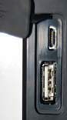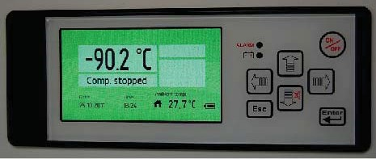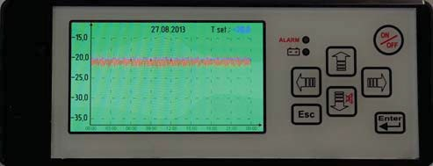On/off or exit menu

Up, down, left,
right button to scolls through the menu

4 5 6 7 8
Return
Mute alarm
Enter (accesses the menu, accept)

USB Data download

Control Panel Description
- Temperature indicator
- Alarm indivator
- Alarm-icons
- Compressor indication
- Date indication
- Hour indication
- Ambient temperature indicator
- Battery level
- USB-Connection

Push the UP button in order to generate a graph.

Push the LEFT button in order to return up to 10 days back.

Push the Esc button in order to exit the menu.

Setting icons

Custom Settings

Custom Settings

Advanced Settings

Advanced Settings

Advanced Service Settings

Advanced Service Settings

Status
S
s

Change / Reset password

Change / Reset password

Custom Settings

Enter password
The menu Custom setting is protected with a password, wich is “0000” to access the menu.

Under the menu Setpoint the temperature for the unit will be set.
Setpoint

Under the menu Alarm Settings the below menu will be avaible.

Under the menu Select language you can select the desired language.

The menu Alarm delay is the settings of the time from an alarm will occur on the unit and until it will be shown on the display.
(Only temperature alarms)

The menu Door open alarm is the settings of the time from an alarm will occur on the unit and until it will be shown on the display.

The menu High temp. alarm is the settings of the highest temperature the device must be in- side before it comes with an alarm.

The menu Low temp. alarm is the settings of the lowest temperature the device must be in- side before it comes with an alarm.

Probe eprom failure

The Probe eprom failure alarm indicate, that the probe is not working.

The Power failure alarm indicate, that there is no power to the unit.

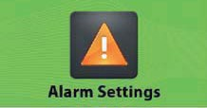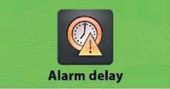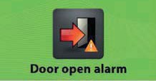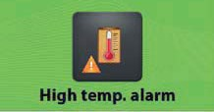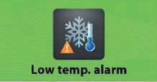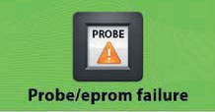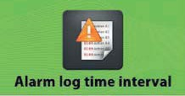

The menu Alarm log time interval is the settings of time for the controller to log data from the unit.

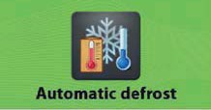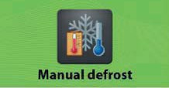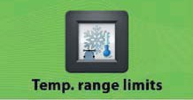
Advanced Settings

Enter password
The menu Advanced Settings is protected with a password wich is “0000” to access the menu.

The menu Calibration is the settings for offset of the tempe- rature in the display.

The menu Automatic defrost is the setting of the time where a defrost automatic will be performed on the unit.

Under the menu Manual defrost the deftrost can be started immediately.

The menu Hysteresis is the setting of the different from the setpoint whwere the compressor will start and stop.

The menu Temp. range limits is the settings of the maximum and minimum temperature the unit can be used for.

Service
Service

The menu Password protection is the setting of the protection for the unit not to be turn off and is protected with a password.
Password protection

The menu Set date / time is the setting of date and time.

The menu Ambient temp. settings is the adjustment of the ambient temperature.

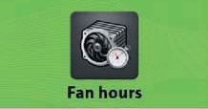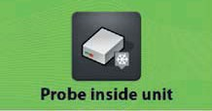Service Settings
Under the menu Service, there is information about the unit, which is important for service on the unit.
Service

The menu Compressor hours shows, how many hours the compressor has run.

The menu Fan hours shows, how many hours the fan has run.

Under the menu Probe the temperature for the sensor mounted in the unit is displayed.

Under the menu Probe inside unit the tempe- rature of the sensor mounted inside the unit is displayed. There is mounted a sensor as stan- dard in the unit, but it is possible to mount 3 sensors inside the device. (Controller version)

Probe Compressor

Probe evaporator
Under the item Probe Compressor the temperature of the sensor mounted on the compressor is displayed.
(Not all models)

Under the point Probe evaporator the tempe- rature of the sensor, that is located on the condenser, is displayed.

Advanced Service Settings

Advanced Service Settings
This menu is only used by the service department at the manufacturer.

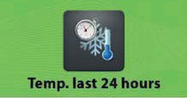The Current alarms shows the alarm, which have been on the unit with data and time.
Status

The Temp. last 24 hours shows the temperature of the unit the last 24 hours.

/ Reset password
Change

Under Change password it is possible to change the password for Customer Settings, Advanced Settings and Advanced Service Settings.

Under Reset password it is possible to reset the pass- word for the Customer Settings, Advanced Settings and Advanced Service Settings.
Contact the manufactorer to get the password for reset password.

Download Data

Place the USB pen drive in the connection on the display and press the button right for read data from the unit to the USB pen.
USB connected

The Read data will be shown in the display when the data is loading to the USB pen drive.

The Transfer complete will be shown on the display when the loading is finished and
the USB pen can be removed from the display.

Open the 2 files:
data00 and param00
on a computer in Excel or similar.

Upload Data

(Only for new settings from the manufactury)

Turn-off the display before start.
Place the USB pen drive in the connection on the display and press the button left for upload parameters from the USB pen to the unit.
USB connected

The Data upload will be shown in the display when the data is loading to the unit.

The Transfer complete will be shown on the display when the loading is finished and
the USB pen can be removed from the display.

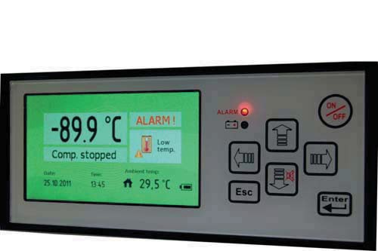Alarms on display

Alarm icons

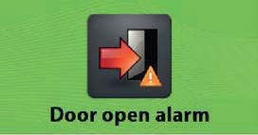
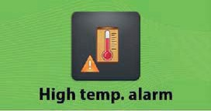
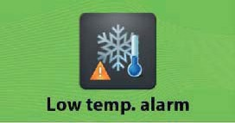

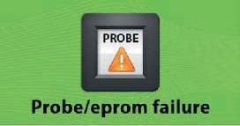

Probe eprom failure

The Door open alarm indicate, that the door is not correct closed

The High temperature alarm indicate, that the temperature inside the unit is higher than permitted from setting of the unit.

The Low temperature alarm indicate, that the temperature inside the unit is lower than permitted from setting of the unit.

The Probe eprom failure alarm indicate, that the probe is not working.

The Power failure alarm indicate, that there is no power to the unit.


The Low battery alarm indicate, that the power on the battery is to low.

5e. Default settings

Description | Arctiko default settings | Customer settings
Custom Settings (Password) | 0000
Set po int
Refrigerator | +4,0
Alarm Settings:
Alarm delay
Refrigerator | 15 min
Door open alarm
Refrigerator | Enable
High temp. alarm
Refrigerator | +6
Low temp. alarm
Refrigerator | +2
Probe/eprom failure
Refrigerator | Enable
Power failure
Refrigerator | Enable
Alarm log time interval
Refrigerator | 1

Description | Arctiko default settings | Customer settings
Advanced Settings (Password) | 0000
Calibra tion
Refrigerator | 0,0
Automatic defrost
Refrigerator | 06
Manual defrost
Refrigerator | OK
Hysteresis
Refrigerator | 1,0
Temp. range limits
Refrigerator Max. | +10,0
Refrigerator Min. | +1,0



50 81 509-02-GB

